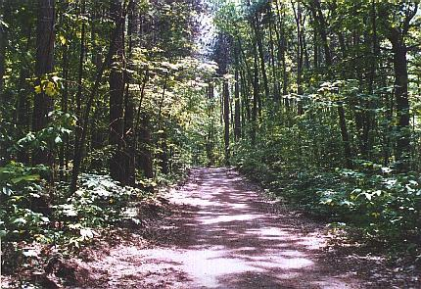
ESCI 530 Field Geology Project 3:
Comparing Methods for Measuring Elevation at the UNH Foss Farm

Abstract:
Topographic maps are an essential tool for geologists, they provide a three-dimensional landscape view on a two-dimensional map. Through these, geologists are able to identify the elevation and location of valleys, and peaks and is able to know if they are uphill, downhill, or level on a particular trail or path, as well as locate surface features (Land Surveying, 2018). In the context of surface features, topographic maps are able to show how different rock types make up landforms (e.g. less resistant sedimentary rocks will often form valleys). The objective of the project is to use a variety of methods to measure a topographic profile in UNH’s Foss Farm area. Then compare the results that were obtained from these different methods and evaluate each of their strengths and weakness.
The field area had few hills and valleys thus implying it was a good place to measure and record elevations for the topographic profile. It was evident that the path wasn’t straight and, in some areas, there would be a hill and the path was cut between it and there were few outcrops that were sticking out. Using the Brunton compass and stadia rod, the elevation of the sections of the path was recorded as well as the GPS waypoints. The data collected was used to create a graph to compare the different methods of measuring elevation. The results reflected that there were few differences from using the various methods but the Google Earth method seemed to inaccurate since data on the graph looked straight implying that there weren’t specific areas of elevation gain and loss.
Introduction:
Measuring elevations and plotting them onto a topographic map, helps as it shows the height of a location above Sea Level. The goals of the project are to measure a topography profile of the UNH’s Foss Farm area an compare the data with other methods that are used to measure elevation. Creating a topographic profile of the field area was done through measuring the elevation gain and loss with the stadia rod, compass and GPS. The importance of creating a topographic profile is to provide a representative appreciation in the vertical dimension of the topography within a map area. (UTA) This project was done to compare different methods geologists use to measure elevation as well as identify which method provide better accuracy. The data was later used to then interpret the profile in terms of the local geological history and surficial geology. The methods that were used to measure the elevations were hand leveling, GPS, Google Earth, and LiDar.
Methods:
The first method that was used was hand leveling. With the brunton compass, and the stadia rod, with which a topographic profile was created. After measuring the field area using the pace method, we determined our eye height to the nearest centimeter. Using the bruntun compass, that had a magnetic declination off roughly 15 degrees west, it was used for an eye level. Starting at one side of the transect, a pace was created and that leveled the way along the path. As this was done, recordings were being taken for the distance and vertical eye height on the stadia rod for each segment.
Taking down the GPS waypoints, was the second method that was used to measure elevation. Global Positioning System (GPS) was used to determine the longitude and the latitude as well as the elevation of the nodes. The GPS was synched with at least four satellites to try and secure accuracy. With the data that was collected with the GPS, it was plotted onto Google Earth and this was the third method that was used to measure elevation. After creating a path with the waypoints that were recorded, it showed the elevation profile. The last method that was used was LiDAR (light detection and ranging), it uses laser pulses to measure distances to features on the Earth. For this the WGS84/UTM zone 19N was used and it shows the area that it between 72°W and 66°W, northern hemisphere between equator and 84°N (ESPG). By adding the GPS waypoints and the Durham LiDAR, the data was used to make the elevation profile with the distance on the x axis and the elevation on the y axis.
Results:
The goal is to compare the different methods of measuring elevation therefore evaluating their strengths and weaknesses. At the field site, whilst measuring the elevation, it was important to draw the topography of Foss Farm. The scale that was used was 1 cm = 30 m for the x-axis (elevation) and 1 cm = 1 m for the y-axis (distance). Using the hand leveling method, the measurements were plotted down and it was used to create the topography map. The vertical exaggeration calculated was 30x. With the GPS locations, the elevations were easy to attain through the waypoints that were saved. But after it was imported into Google earth, it was essential to create a path which implied the field area transect that was walked. With this data, an elevation profile would show up and based on the waypoints shown in google earth, and it was possible able to determine the elevation.
For the LiDAR, the GPS waypoints had to import the waypoints again as well as the Durham, LiDAR_UTM. This showed a quantitative representation of the terrain and is important for Earth science and hydrological applications (Sandip Mukherjee, 2012). The data that was obtained from the different methods to measure the elevation, it was used to create a table in excel with the distances and the elevation corresponding in order to create a topography map. Bringing this together, it helps evaluate and compare the different methods that were used to measure the elevation of the UNH Foss farm along the railroad path.
Discussion:
There weren’t any similarities in the methods that were used. For the GPS, Google Earth, and the LiDAR, the GPS waypoints were essential and were used to create the topographic profile. For the hand leveling, the results that were recorded were different from the results from the other methods. The elevation of the nodes was taken by calculating the difference between the true eye height and the level height. The results were both positive and negative and it implied the difference in the topography, which was evident in the graph that was drawn. Some of the factors that would affect the data collected, were the mosquitoes that were biting us and this caused few hand movements while holding the stadia rod. Another factor was reading the compass toward the stadia rod, there were times when the bubble wasn’t centered and this would have caused an error in the measurements.
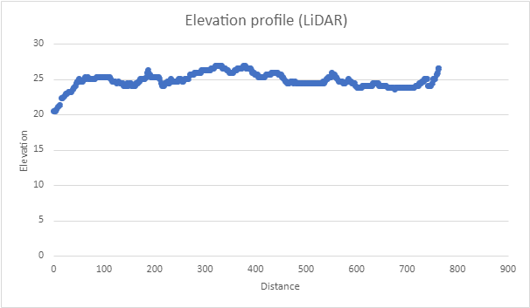
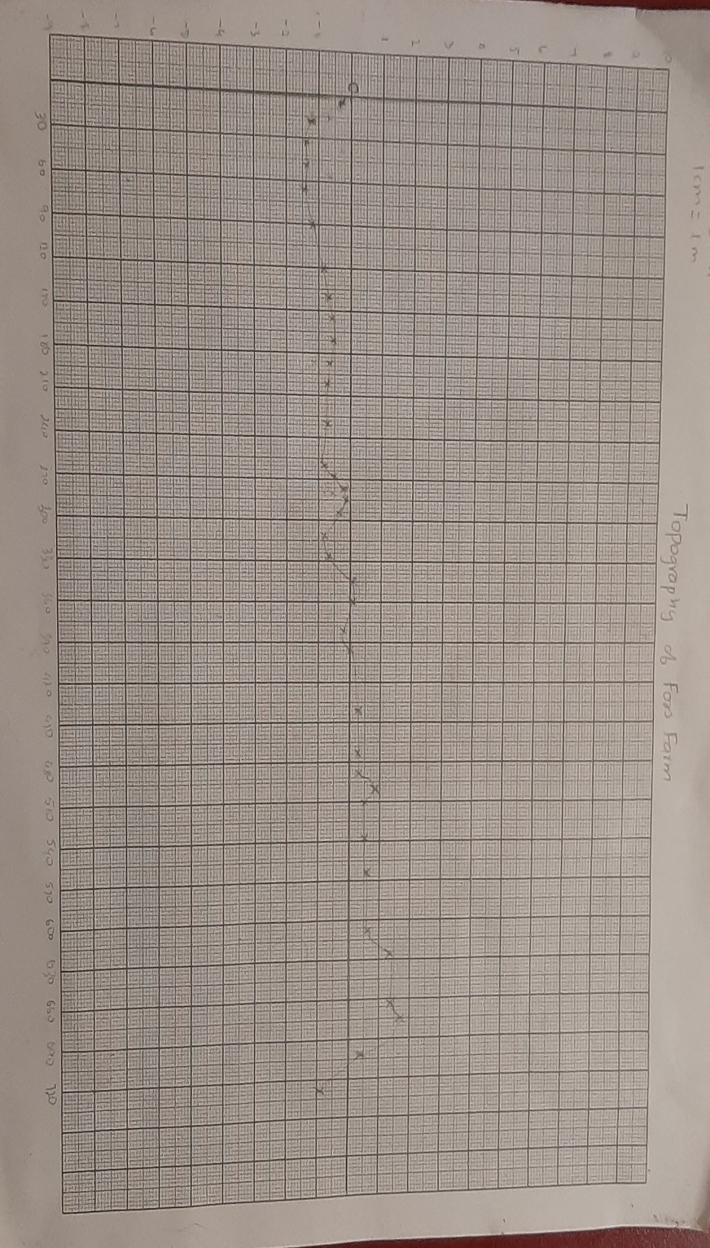
For the other methods that used the GPS waypoints, there were different errors that can be pointed out. The second method was the quickest and easiest method to record the elevations. Looking into the GPS, waypoints, the elevations were already recorded in there. And looking at the graph, it is possible to see a topographic profile, although it isn’t as clear as the hand leveling methods. There are some ups and downs implying the different elevations in the field area. Importing the same GPS waypoints into Google Earth, was the third method that was used to measure elevation. Google earth has the option of seeing the elevation profile after a path is created through the waypoints. But looking at the graph, the elevations that were obtained through google earth was an anomaly. The line on the graph looks straight which implies that weren’t any elevation gain or loss in the field area. This clearly shows that Google Earth isn’t a reliable method to measure elevation. The last method that was used to identify the elevation profile was LiDAR, and it seemed to be the most complicated but the line had a changing gradient which implies the change in elevation. LiDAR was more precise than any other method, since the elevation was measured for every few meters leaving less room for error.
Figure 2. Elevation profile of UNH Foss Farm through LiDAR. Using the GPS waypoints and the DurhamLiDAR_UTM file, an elevation profile was created.
Figure 1. Topography of Foss Farm railroad path. The vertical exaggeration of the graph is 30x.
Figure 4. Elevation profile of UNH Foss Farm through GPS waypoints. The elevations were measured using the GPS.
Figure 3. Elevation profile of UNH Foss Farm through hand leveling. This method was done through taking the difference between the individual's eye height and the level height

Figure 5. Elevation profile of UNH Foss Farm through Google Earth. After importing the waypoints into Google earth and creating a path, an elevation profile is made.
Conclusions:
Each of the methods performed differently therefore the results varied. Comparing all the methods, the Google Earth elevation profile, wasn’t accurate and seem to be the anomaly. While the other three methods showed elevation gains and lose, looking at the Google Earth profile there seem to be less evidence to show the change in topography. The LiDAR elevation profile had more measurements taken within the Foss Farm area which could imply that the profile is more precise but in terms of accuracy it is hard to read the elevation change. But the GPS waypoints, although having the same number of measurements, the profile looked clear and it is evident that there is a change in the topography. Even though it doesn’t look similar to hand leveling method, it is accurate and where there are changes in elevation, we can infer the surficial geology.

References:
Topographic profile construction. Date accessed October 13, 2021. https://boundaryzone.com/the-importance-of-topographic-maps/
Boundary Zone. July 27, 2018. The Importance of Topographic Maps. Date accessed October 13, 2021 https://www.uta.edu/paleomap/geol1435/topocons.htm
International Journal of Applied Earth Observation and Geoinformation. October 15, 2012. Evaluation of vertical accuracy of open source Digital Elevation Model (DEM). Date accessed October 13, 2021 https://www.sciencedirect.com/science/article/pii/S030324341200195X
WGS 84 / UTM zone 19N. EPSG :32619. Date accessed October 13, 2021. https://epsg.io/32619

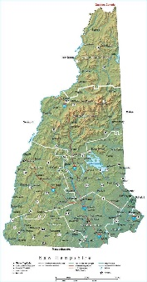
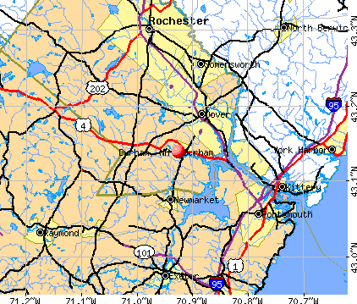
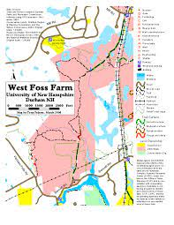
Index Map

